Nexora workflow designer and runtime
Document 22 of the Nexora learning guides
Source snapshot 13 October 2026 at 17:12 UTC
Understand workflow drafts, nodes, validation, publishing, activation, runs and operational gates.

Recognise the screen and its scope
Open /workflow-designer, /workflow-designer/content-preview/[pageId]/[revisionId]. CRM routes use port 3017; member routes use 3018; public website routes can use 3019. Brackets name a route parameter, not text to paste into a browser. Choose a real record or site id from the application.
This guide covers Catalogue and inactive draft templates; Canvas nodes conditions queries and variables; Triggers field changes and schedules; Validation version publishing and activation; Approvals exceptions and run history; Connectors delivery reconciliation import export and AI draft.
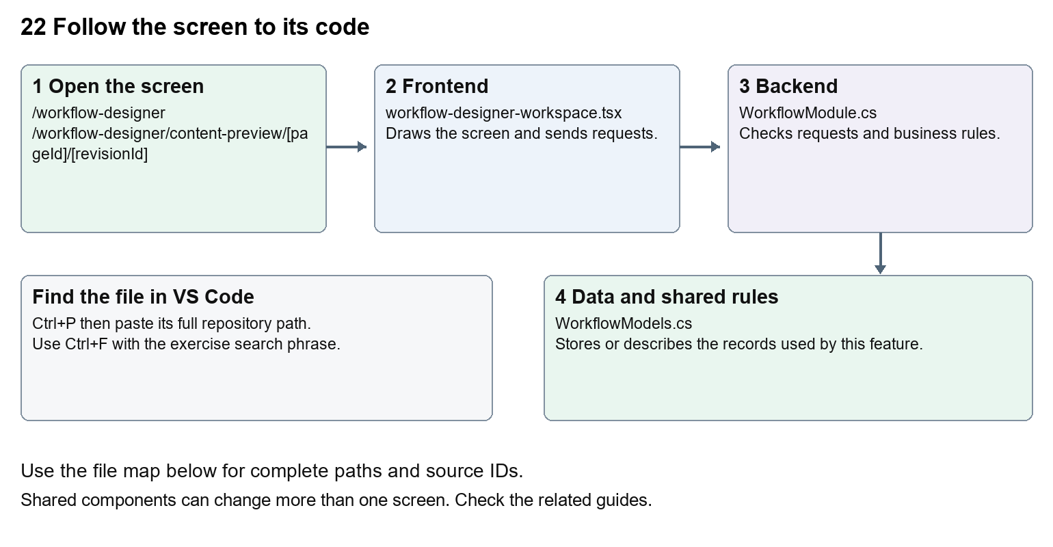
The diagram shows the file roles. The full paths below are what you paste into Ctrl+P.

Find the files in VS Code
Role | File and source ID | What it does
Screen | S0156 workflow-designer-workspace.tsx | Main UI or route for this topic
Server | S0564 WorkflowModule.cs | Endpoints or server rules
Data | S0563 WorkflowModels.cs | Data shape or persistence structure

Screen S0156
apps/web/src/features/workflows/workflow-designer-workspace.tsx
Server S0564
backend/src/Modules/Nexora.Modules.Workflow/WorkflowModule.cs
Data S0563
backend/src/Modules/Nexora.Modules.Workflow/WorkflowModels.cs
The complete HTML manual opens these source IDs inside its Source library. The Word manual shows short labelled extracts so you can learn the flow before reading large files. Each individual Markdown guide includes its complete primary files after the walkthrough.

Follow the request and the records
1. The designer loads metadata, definitions and permissions.
2. A draft graph contains typed nodes and connections.
3. Validation checks graph structure, conditions and action inputs.
4. Publishing creates a version; activation separately enables its triggers.
5. The processor records runs, steps, approvals, exceptions and delivery outcomes.

Read the code with an explanation
A graph is a set of steps and links. A draft is editable; a published version is the reference used by runs. Activation controls whether eligible triggers start it. Saving a diagram does not execute it. WorkflowProcessor and registered module actions perform server work, with gates and persisted state. Preview, test, publish and execute have different consequences.
Source reference S0156 apps/web/src/features/workflows/workflow-designer-workspace.tsx
Selected opening lines with their original numbers. The complete file is in the HTML source library.
0001 "use client";
0003 import Link from "next/link";
0004 import { useCallback, useEffect, useId, useState } from "react";
0005 import { PanelToggle, useCollapsedPanel } from "@/features/shared/panel-toggle";
0006 import {
0007 ArrowLeft,

The import lines lead to shared components and helpers. Start at the exported component or route function; follow the request helper to the server rather than assuming the whole feature lives in this file.
Source reference S0564 backend/src/Modules/Nexora.Modules.Workflow/WorkflowModule.cs
Extract from source line 33. A fragment from a long line is shown without the rest of that line.
0033 api.MapGet("/metadata",(IEnumerable<Nexora.BuildingBloc

On the server, look for MapGet to load records, MapPost to create or perform an action, MapPut or MapPatch to change data, and RequireAuthorization for permissions. Some shared methods register endpoints indirectly. Find SaveChangesAsync to see the database write. A request method alone does not tell you every side effect.
Source reference S0563 backend/src/Modules/Nexora.Modules.Workflow/WorkflowModels.cs
Selected opening lines with their original numbers. The complete file is in the HTML source library.
0001 using Nexora.BuildingBlocks.Persistence;
0002 using Nexora.BuildingBlocks.Domain;
0003 namespace Nexora.Modules.Workflow;
0004 public sealed class WorkflowDefinition:TenantEntity
0005 {
0006 public string Name{get;set;}=""; public string Description{get;set;}=""; public string DraftJson{get;set;}="";

Follow model fields to their request names and database mapping. An id points to a particular record. A tenant id limits the organisation. A version or concurrency stamp protects newer edits. Some model files describe contracts rather than tables; check the owning DbContext before assuming storage.

Make or trace your first change
1. Press Ctrl+P and open apps/web/src/features/workflows/workflow-editor.tsx.
2. Press Ctrl+F and search for Drag nodes to arrange. Set connections in node settings.. In this snapshot it appears at line 13.
3. Replace only the canvas help sentence. Open a draft and inspect the canvas. Do not publish, activate, install templates or execute it during this wording exercise.
4. Replace only Drag nodes to arrange. Set connections in node settings. with Drag steps to arrange them. Choose links in step settings. in that intended location. Keep quotes, tags, JSON keys and routes intact.
5. Save with Ctrl+S. Inspect Problems and the local screen. Review the diff and restore the original text when you finish practising.
Extract from source line 13. A fragment from a long line is shown without the rest of that line.
0013 tZoom(1)}>Reset view</button><span>Drag nodes to arrange. Set connections in node settings.</span></div><div className={`${vertical?"h-[

These exercises have not been applied to the application. Their search phrases are verified against the captured source. Line numbers can move; the phrase and file path are your main navigation aids.

Check a change and diagnose problems
Confirm the original screen still loads, the changed words appear in the intended place, and another screen using the same component still behaves correctly. If an action fails, inspect the browser Network response, the relevant helper and server validation message. Use the common error table at the beginning of the manual. Reload on a version conflict instead of removing the version check.
A syntax error after a text edit usually means a quote, brace or closing tag changed. Compare your diff with the original. An unchanged browser result can mean the wrong port, a saved published configuration overriding a default, or a running API that has not reloaded.

Understand the current limits
A queued email or connector delivery is not confirmed external delivery. Provider availability and reconciliation are separate. Template installation creates records, and execution can alter operational data. Trace permissions and action capabilities before enabling a workflow.

Continue learning
Related guides 10 Nexora membership applications and decisions, 15 Nexora sales and finance, 17 Nexora tasks and notifications, 21 Nexora automation controllers, 27 Nexora website editor and publishing.

